Newsletter December 2017

Three sleeps to Christmas and the shortest day of the year has just passed.

As you know we have been busy during the advent period, counting down the days to Christmas with our Advent Calendar and Advent Wreath on display.
Well done to all the children in infant classes who did good deeds and got their names on a star hanging near the Advent Wreath.
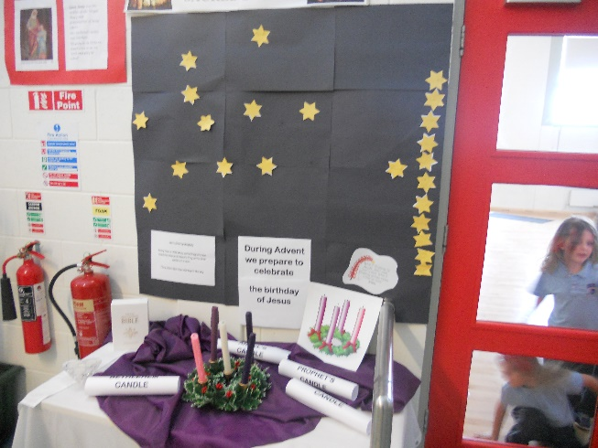

Also to everyone who put decorations on the Christmas tree.
Remember we are involved with the Ardclough Village Centre committee in organising a recycling of trees on Jan 6th and 13th from 10-4pm. Our Green Team have been busy making posters for this so watch out for these around the village.
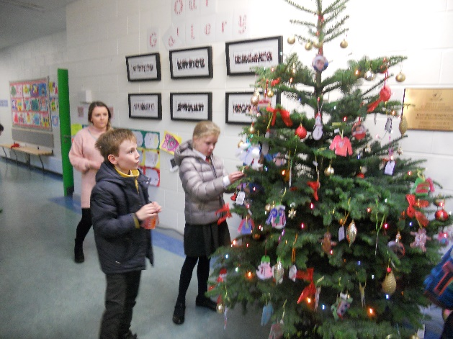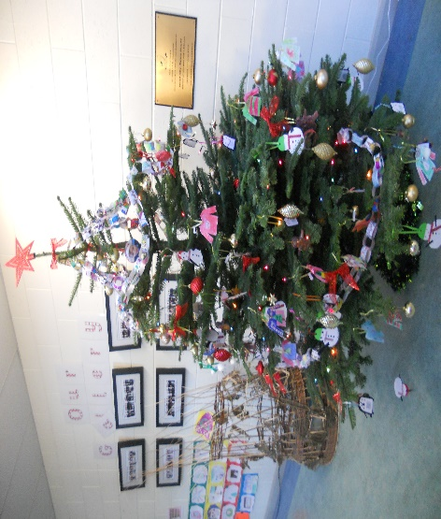

A special thank you to children in Ms Owens class and those from other classes who brought cards and gifts for homeless children. We welcomed Pat Doyle from the Peter Mc Verry Trust yesterday to collect all that was donated. Children made a human chain to load the parcels, cards and vouchers into the van. They will be delivered to children in Kildare today.
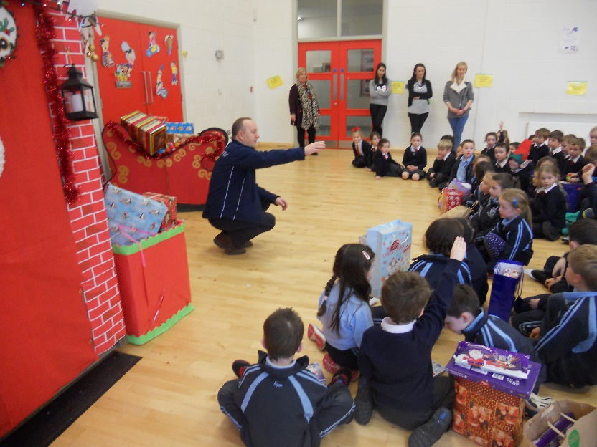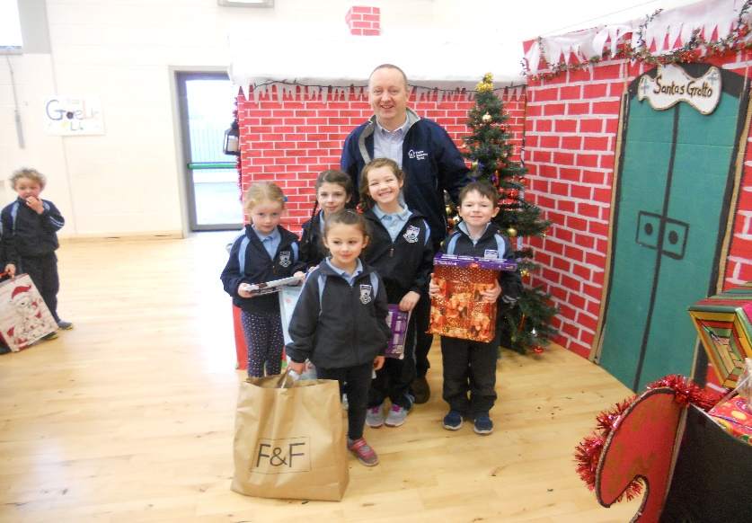

Well done to everyone for the lovely festive art displays around the school. From candles to Christmas scenes and an impressive model of the stable from 4th class.
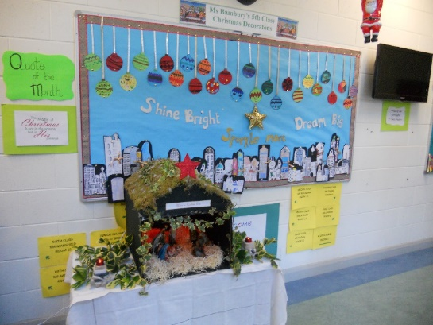
They add so much to the Christmas atmosphere here!
We are very grateful to the Graham family for supporting us in setting up our live crib on Monday last. Also to the children in 3rd class who dressed up to create the characters for the Christmas story. 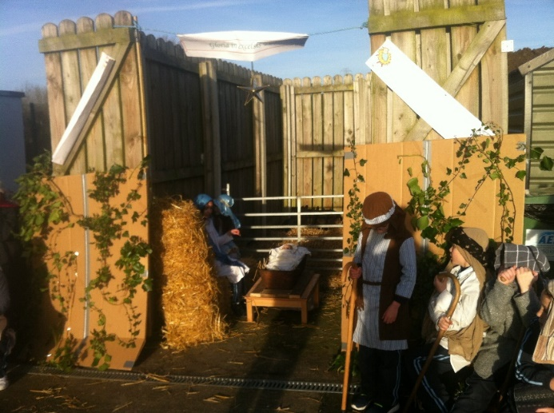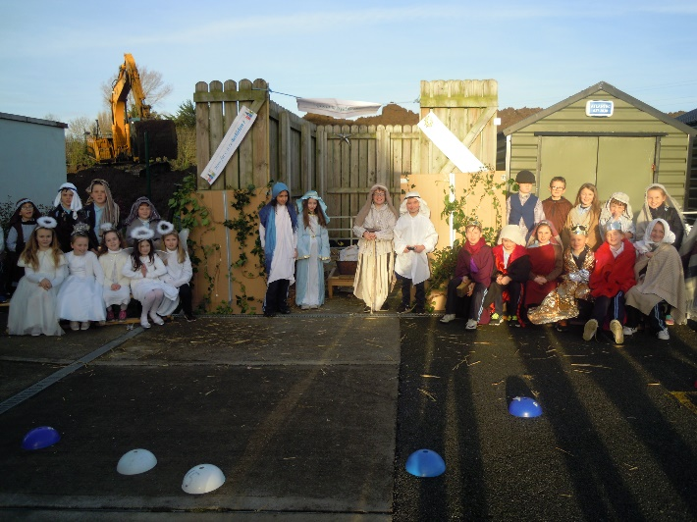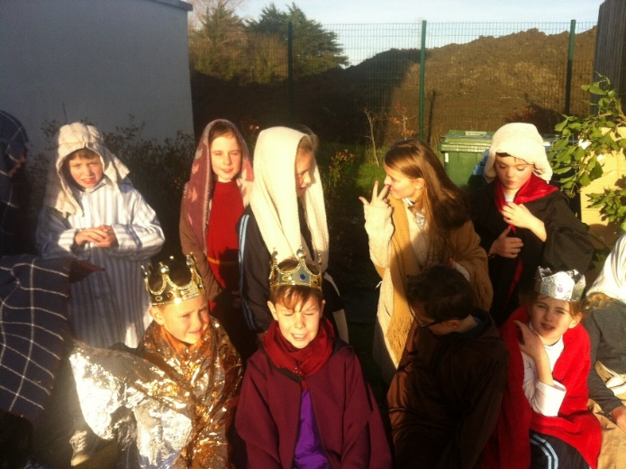
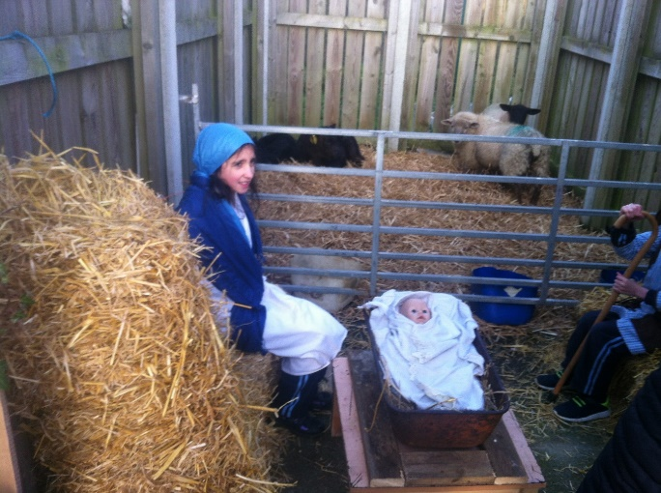

Santa took some time off from his hectic schedule this week to come and visit us. Mind you he was in a spot of bother as he was caught by the Gardaí and brought to the school in a Garda van. Thankfully the Student Council were able to rescue him and he brought selection boxes for everyone.
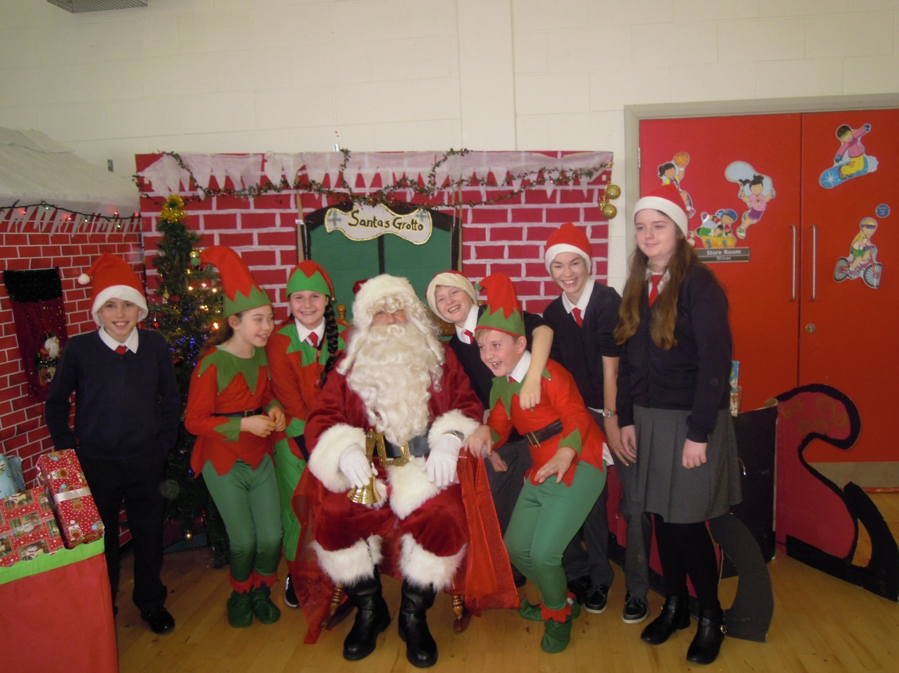

Our Carol Service was held on Wednesday 20th. Many children read the story of Jesus birth and each class group sang carols. Thank you to the 4th-6th class choir for singing so well and well done to all the soloists and readers.

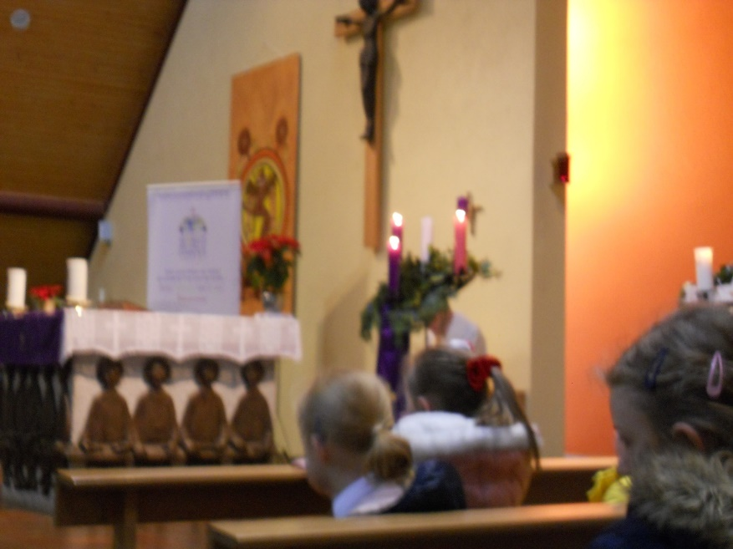

The children in 6th class led clubs for the term on Wednesdays at lunchtime. One club was for dance and gymnastics- they put on a performance in the hall yesterday for classes. It was a great achievement. Also the drama club were involved in writing, performing and filming a play called
The Awful Christmas.

Well done to everyone in 6th class for taking on this responsibility so well this year.

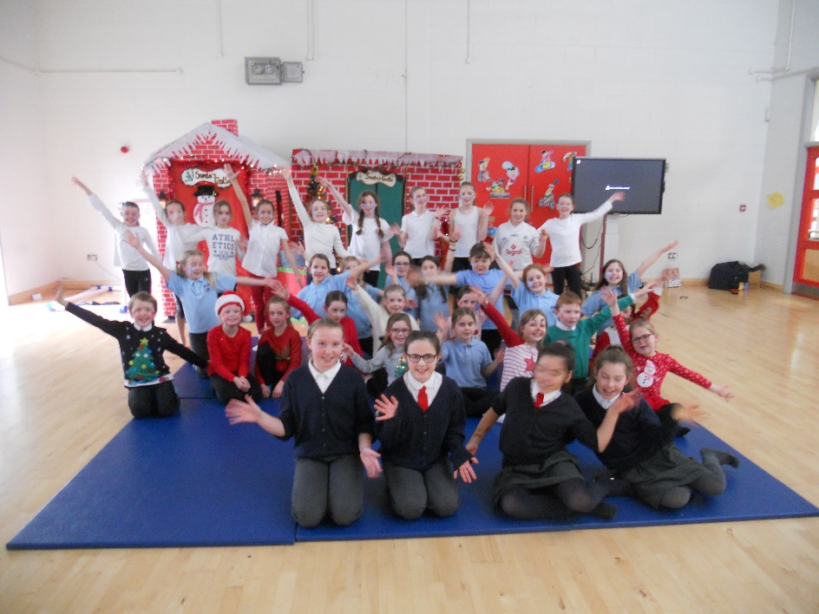
All the photos of the various events will be on the St Anne’s website gallery for you to view.

Christmas Holidays:
We will break for Christmas holidays on Friday Dec 22nd at 12.30pm (infant classes will leave at 12.20). School re-opens on Monday January 8th 2018.

May I take this opportunity to wish you all a very happy and peaceful Christmas and every good wish for 2018. Thanks to all who support St Anne’s in so many ways and to each and every child who makes Christmas so special for us all.

